**Quick set up for Mattias MTS**

1. Download and unzip the Dropbox file
2. double click APE_COGNTION_6_0.jar to open
3. Under File in the header bar select “open config file” and open “Mattias_Config.txt”
4. On the control panel, click “Run Task”
5. Enlarge Test Screen as desired, or move to a second attached screen
6. When expt is over, data can be found in “AC_trials” folder

**how it works**

The Lexigrams folder contains all of Kanzi’s lexigrams which you are free to use as distractor items.

First, create a new file in the “fixedTrials” folder. The example I created is named Matt1.csv It is important that you create this file using a text editor like TextPad. Although the file can be read in Excel, creating it in Excel introduces weird characters that screw up the program unfortunately.

The first line lists the column headers and should not be changed or altered in any way.

Each trial is described on a separate line, In the file below we have 12 trials. I created them in pairs, first a regular mts test of one of Kanzi’s words followed by a test of your special type sounds and pictures.

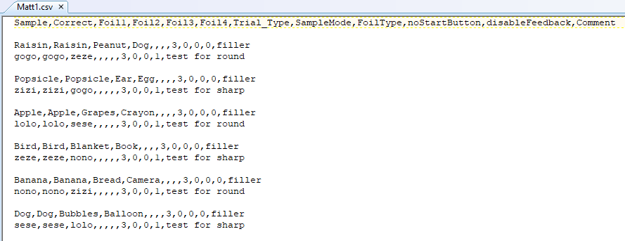

Trial 1 is saying

the sample to test is Raisin  
the correct match is Raisin  
the two foils are Peanut and Dog  
The numbers 3,0,0,0  
mean  
- sample mode is 3, present sound only  
- foil type is 0, show a random picture of each named foil item from a similarly named pictures folder  
- noStartButton is 0, that is, you should show the start button  
- disableFeedback is 0, means give feedback – the right and wrong sound

Trial 2 is saying 3,0,0,1 which means

present gogo sound  
then show a random picture from the associated gogo pictures folder (one of the three round shapes)  
show the start button  
but this time DO disable feedback.

If you view this in Excel it looks like this (but, again, do NOT do your editing in excel, just viewing)

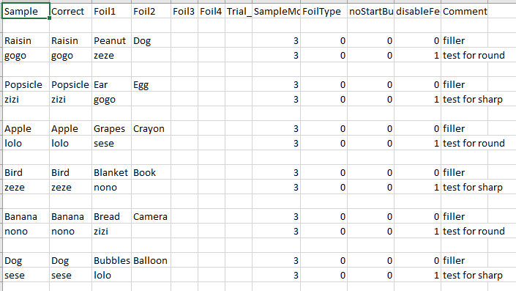

How to create the required folders for the stimuli objects.

This is going to seem a little weird to you but you have to remember that this MTS was designed to test Lexigrams and their matching sounds and pictures. So....

The easiest way to think of how to set up your design is to pretend for the moment that the words “gogo”, “lolo” , “nono”, “zeze” etc represent lexigrams to be tested.

* Step 1 Add a new folder “gogo” inside the Lexigrams folder where all the other lexigrams appear. Normally a lexigram folder contains the lexigram picture itself and its sound. In this case there is no lexigram just the sound so add the gogo.wav to the folder
* Step 2 Add a new folder also named “gogo” to the Pictures folder. Note that each of these folders contains any number of images that represent the named lexigram. You can add as many round pictures as you want and one will be randomly chosen for testing each time. it doesnt matter what you name them.

You are probably saying, sheesh, the picture folders gogo, nono, and lolo all contain the same3 round images.. do I really need separate folders. Yes, you do.. remember this mts was designed for testing discrete lexigrams so this is a work around, heh. The program is looking for the matching pictures in the picture folder of the same name as the lexigram folder.

If have already created the folders for the stimuli you gave me. 6 new “lexigram” folders, 6 new “picture” folderss.

**Creating the Config File**

I have created a config file named Mattias_Config.txt in the AC_modes folder. It looks like this: (don’t use the horribel NotePad to edit, it creates havoc with line endings... use something like TextPad)

Here is a PARTIAL listing of that file (view in Textpad for full version)

How was this created? It was created first by running the program and filling in the selected values in the config panel and then saving the program. This is what the saved file looks like. A couple of things are relevant here.

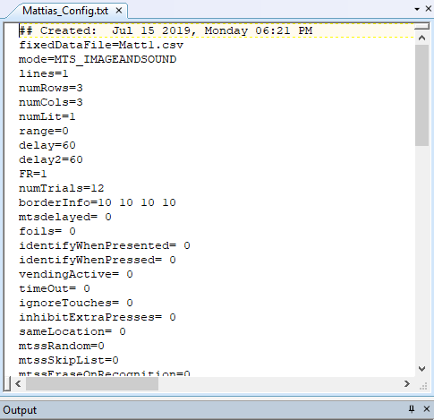

- First, you must indicate that you are using “Matt1.csv” as your fixed data file that describes the trials.

- a lot of these values are overridden by the fixed data file so don’t worry about contradictions, the fixed data file takes precedence

- numTrials = 12, change this if you add trials

Other than that just use these suggested values.. if you want to play around, bring up this file in the app, edit it, save it again... or just edit with a text editor.

If you have any questions just drop me an email!

cheers,

Ken